# Appendix C - Forming a Linear Equation on a Grid Node

Again we consider **Eq. A4**, with a bit rearrangement,

$$\begin{matrix}\left[\begin{matrix}differential \\ in t\end{matrix}\right]-\left[\begin{matrix}differential \\ in x direction\end{matrix}\right]-\left[\begin{matrix}differential \\ in y direction\end{matrix}\right]-\left[\begin{matrix}differential \\ in z direction\end{matrix}\right] & =\frac{{\dot{m}}_{sc}}{V_{b}}\end{matrix}$$

$$\begin{matrix}\begin{matrix}differential \\ in x direction\end{matrix} & =T_{x+\frac{Δx}{2}}^{t}P_{x+Δx}^{t+Δt}-\left(T_{x+\frac{Δx}{2}}^{t}+T_{x-\frac{Δx}{2}}^{t}\right)P_{x}^{t+Δt}+T_{x-\frac{Δx}{2}}^{t}P_{x-Δx}^{t+Δt} \\ \begin{matrix}differential \\ in y direction\end{matrix} & =T_{y+\frac{Δy}{2}}^{t}P_{y+Δy}^{t+Δt}-\left(T_{y+\frac{Δy}{2}}^{t}+T_{y-\frac{Δy}{2}}^{t}\right)P_{y}^{t+Δt}+T_{y-\frac{Δy}{2}}^{t}P_{y-Δy}^{t+Δt} \\ \begin{matrix}differential \\ in z direction\end{matrix} & =T_{z+\frac{Δz}{2}}^{t}P_{z+Δz}^{t+Δt}-\left(T_{z+\frac{Δz}{2}}^{t}+T_{z-\frac{Δz}{2}}^{t}\right)P_{z}^{t+Δt}+T_{z-\frac{Δz}{2}}^{t}P_{z-Δz}^{t+Δt}+\left(-T_{z+\frac{Δz}{2}}+T_{z-\frac{Δz}{2}}\right)ρgΔz \\ & \\ \begin{matrix}differential \\ in t\end{matrix} & =\frac{ϕρc_{T}}{Δt}\left(P_{x,y,z}^{t+Δt}-P_{x,y,z}^{t}\right) \\ & \\ T_{s} & ={\left(\frac{ρkA_{s}}{μV_{b}Δs}\right)}_{s}\end{matrix}$$

Each of these differential terms (with respect to $t$, $x$, $y$, and $z$) is translated accordingly to form the diffusivity equation for one particular point. This will form a linear equation with some unknown $P^{t+Δt}$ terms and known $P^{t}$ variables. Notice that we will get the term $P^{t}$ only when performing differential with respect to $t$. Also, we will get a known term when performing differential with respect to $z$. Therefore, we rearrange the equation further as follows,

$$\begin{matrix}\frac{ϕρc_{T}}{Δt}\left(P_{x,y,z}^{t+Δt}\right)-\left[\begin{matrix}differential \\ in x direction\end{matrix}\right]-\left[\begin{matrix}differential \\ in y direction\end{matrix}\right]-\left[\begin{matrix}differential' \\ in z direction\end{matrix}\right] & =\left[\begin{matrix}known \\ right hand side\end{matrix}\right]\end{matrix}$$

where:

$$\begin{matrix}\left[\begin{matrix}differential' \\ in z direction\end{matrix}\right] & =T_{z+\frac{Δz}{2}}^{t}P_{z+Δz}^{t+Δt}-\left(T_{z+\frac{Δz}{2}}^{t}+T_{z-\frac{Δz}{2}}^{t}\right)P_{z}^{t+Δt}+T_{z-\frac{Δz}{2}}^{t}P_{z-Δz}^{t+Δt} \\ \left[\begin{matrix}known \\ right hand side\end{matrix}\right] & =\frac{{\dot{m}}_{sc}}{V_{b}}+\frac{ϕρc_{T}}{Δt}\left(P_{x,y,z}^{t}\right)+\left(T_{z+\frac{Δz}{2}}-T_{z-\frac{Δz}{2}}\right)ρgΔz\end{matrix}$$

We can form the following matrices,

$$\begin{matrix}\begin{matrix}differential \\ in x direction\end{matrix} & =\left[\begin{matrix}T_{x+\frac{Δx}{2}}^{t} & & -\left(T_{x+\frac{Δx}{2}}^{t}+T_{x-\frac{Δx}{2}}^{t}\right) & & T_{x-\frac{Δx}{2}}^{t}\end{matrix}\right]\left[\begin{matrix}P_{x+Δx}^{t+Δt} \\ \\ P_{x}^{t+Δt} \\ \\ P_{x-Δx}^{t+Δt}\end{matrix}\right] \\ \begin{matrix}differential \\ in y direction\end{matrix} & =\left[\begin{matrix}T_{y+\frac{Δy}{2}}^{t} & & -\left(T_{y+\frac{Δy}{2}}^{t}+T_{y-\frac{Δy}{2}}^{t}\right) & & T_{y-\frac{Δy}{2}}^{t}\end{matrix}\right]\left[\begin{matrix}P_{y+Δy}^{t+Δt} \\ \\ P_{y}^{t+Δt} \\ \\ P_{y-Δy}^{t+Δt}\end{matrix}\right] \\ \begin{matrix}differential' \\ in z direction\end{matrix} & =\left[\begin{matrix}T_{z+\frac{Δz}{2}}^{t} & & -\left(T_{z+\frac{Δz}{2}}^{t}+T_{z-\frac{Δz}{2}}^{t}\right) & & T_{z-\frac{Δz}{2}}^{t}\end{matrix}\right]\left[\begin{matrix}P_{z+Δz}^{t+Δt} \\ \\ P_{z}^{t+Δt} \\ \\ P_{z-Δz}^{t+Δt}\end{matrix}\right]\end{matrix}$$

# Appendix D - Analytical Solution to 1D- Flow (Example 1)

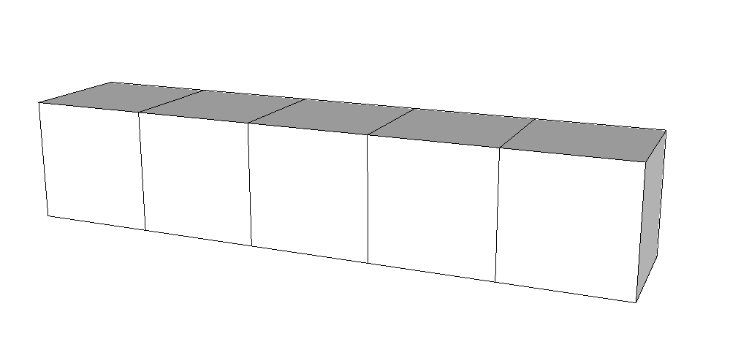

**• 1**

**• 2**

**• 3**

**• 4**

**• 0**

$$\frac{∂P}{∂x}=0$$

$$\frac{∂P}{∂x}=-100 psi/ft$$

75 ft

1000 ft

1000 ft

Figure - Porous medium and grid block system for Example 1

For the 1D-flow through gridblocks as shown in **Fig. 3**, determine the pressure distribution during the first year of production. The initial reservoir pressure is $6,000 psia$. The rock and fluid properties for this problem are $Δx=1,000 ft$, $Δy=1,000 ft$, $Δz=75 ft$, $ρ_{l}=62\frac{lb_{m}}{ft^{3}}$, $c_{l}=3.5×{10}^{-6} psi^{-1}$, $k_{x}=15 mD$, $ϕ=0.18$, and $μ_{l}=10 cP$.

Consider the following partial differential equation (as derived in **App. A** with no sink/source term) with its initial and boundary condition

|  |  |
| --- | --- |
| Partial differential equation (PDE) | |
| $$\begin{matrix}\frac{ϕc_{T}μ}{k}\frac{∂P}{∂t}=\frac{∂}{∂x}\left(\frac{∂P}{∂x}\right)\end{matrix}$$ $$\begin{matrix}for 0≤x≤5000, & t≥0\end{matrix}$$ | |
| Initial condition (IC) | Boundary condition (BC) |
| $$P\left(x, 0\right)=6000$$ | $$\begin{matrix}\frac{∂P}{∂x}=0 & at x=0\end{matrix}$$ $$\begin{matrix}\frac{∂P}{∂x}=-100 & at x=5000\end{matrix}$$ |

First, we need to assume that the only variable that changes with respect to $x$ and $t$ is $P$. All else stay constant. We can rearrange the PDE as follows.

$$\begin{matrix}\frac{∂P}{∂t}=α^{2} \frac{∂^{2}P}{∂x^{2}}\end{matrix}$$

where $α^{2}=\frac{k}{ϕc_{T}μ}$.

***Step 1. Method of Separating Variables***

By **method of separating variables**, we are trying to construct a solution of the form $X\left(x\right)T\left(t\right)$, that is $P\left(x,t\right)=X\left(x\right)T\left(t\right)$. The PDE then becomes

$$\begin{matrix}\frac{∂P}{∂t} & =α^{2}\frac{∂^{2}P}{∂x^{2}} \\ X\dot{T} & =α^{2}X^{''}T \\ \frac{1}{α^{2}}\frac{\dot{T}}{T} & =\frac{X^{''}}{X}\end{matrix}$$

Both sides must be constant. Because say we would like to vary $T$ with respect to $t$ without varying $X$, the left hand side which contains $X$ terms must stay constant. Conversely, varying only the $X$ term can only be done while the right hand side is left unaltered. Say its constant is $k$, we can then get two ordinary differential equations (ODE).

$$\begin{matrix}\frac{1}{α^{2}}\frac{\dot{T}}{T} & =\frac{X^{''}}{X}=k \\ & \\ \dot{T}-α^{2}kT & =0 \\ & \\ X^{''}-kX & =0\end{matrix}$$

***Step 2. Satisfying Boundary Conditions***

1. **Evaluating $T\left(t\right)$**

We are trying to construct a solution of the form $Ce^{rt}$.

$$\begin{matrix}Cre^{rt}-α^{2}kCe^{rt} & =0 \\ Ce^{rt}\left(r-α^{2}k\right) & =0\end{matrix}$$

Therefore, we get $T\left(t\right)=Ce^{α^{2}kt}$

1. **Evaluating $X\left(x\right)$**

We are trying to construct a solution of the form $Ce^{rx}$.

$$\begin{matrix}X^{''}-kX & =0 \\ Cr^{2}e^{rx}-kCe^{rx} & =0 \\ Ce^{rx}\left(r^{2}-k\right) & =0\end{matrix}$$

We have a quadratic equation as its characteristic equation ($r^{2}-k$). The form of $r$ is determined by the separation constant $k$. If $k=0$, then $r=0$ and the solution will be $X\left(x\right)=ax+b$. From the boundary condition, one can show that $a=b=0$, and we will eventually get a zero solution $X\left(x\right)=0$, which will further lead to $P\left(x,t\right)=0$. If $k>0$, say $k=μ^{2}$, a general solution will be

$$X\left(x\right)=Ae^{μx}+Be^{-μx}$$

Again, from the boundary condition, one will eventually obtain $X\left(x\right)=0$ as before. We are now left with $k<0$, say $k=-μ^{2}$. We will get complex solutions as follows,

$$X\left(x\right)=Ae^{μix}+Be^{-μix}$$

By **Euler’s formula**, we can express $X\left(x\right)$ in terms of real solutions,

$$X\left(x\right)=A\cos{μx}+B\sin{μx}$$

After carefully evaluating $X\left(x\right)$ and $T\left(t\right)$ for this problem, we arrive at the following general solution,

$$\begin{matrix}P\left(x,t\right) & =e^{-α^{2}μ^{2}t}\left(A\cos{μx}+B\sin{μx}\right) \\ & \\ \frac{∂P}{∂x} & =e^{-α^{2}μ^{2}t}\left(-Aμ\sin{μx}+Bμ\cos{μx}\right)\end{matrix}$$

$$\begin{matrix}{\left.\frac{∂P}{∂x}\right|}_{x=0} & =0 \\ e^{-α^{2}μ^{2}t}\left(-Aμ\sin{0}+Bμ\cos{0}\right) & =0 \\ e^{-α^{2}μ^{2}t}\left(Bμ\right) & =0 \\ B & =0\end{matrix}$$

$$\begin{matrix}{\left.\frac{∂P}{∂x}\right|}_{x=5000} & =-100 \\ e^{-α^{2}μ^{2}t}\left(-Aμ\sin{5000μ}\right) & =-100 \\ e^{-α^{2}μ^{2}t}\left(Bμ\right) & =0 \\ B & =0\end{matrix}$$